**Basic info**

**Input**, 2 files:

*.wav file

*.cath file

**Output, 2 files:**

**1. Report.txt**

**2. Results:** OutPutRecordFile : file of single;

Results records:

**TresArray=array of single;**

**TOutputRecord = recordord**

**out_sliceNbr : longWord;**

**streamArray : array of TresArray;**

**phon,person,gender,age : char;**

**pF0 : single;**

**end;{record}**

Table 2. Header records

Typecasting for analysis parameters registration

|  |  |  |  |  |  |
| --- | --- | --- | --- | --- | --- |
| **rec**  **ords** | **parameter** | **proce**  **dure** | **used fields** | **Cast** | **type** |
| 1 | count*, NbrOfStreams | analysisParamRegister | out_SliceNbr | longWord(countsRec) | TcountsRec=record  rCount1, rCount2:word  end; |
| recSize, F0count, | streamArray[0,0] | single(countsRec) | ditto |
| pWinShape, pF0WinShape, p0Component,pJump | streamArray[0,1] | single(paramRec) | TparamRec=record  pWinShape, pF0WinShape,  poComponent, pJump:byte  end; |
| allNormChecksStatesCode,  allOutChecksStatesCode | streamArray[0,2] | single(standOutChecksStates) | TstandChecksStates=record rigid, weak : word end;  (used field: rigid, for allNormChecksStatesCode weak is for allOutChecksStatesCode) |
| phonNbr, personNbr, genderNbr, ageNbr | phon, person, gender, age | char(phonNbr|personNbr|genderNbr|ageNbr) | char |
| rate, nbrOfMultimean, frameNbr | pF0 | single(ratePeriods) | TratePeriods=record rRate:word;rNumberOfMultiMean, rFrameNbr:byte end; |
| 2 | 1-th, 2-nd, 3-rd, 4-th cathegory name | cathNamesDescr | all fields | single(encode) | Tencode=array[1..4] of char; |
| 3 | stream names  The $ at the beginning means “standardized” stream | streamsDescr | streamArray | singleInfo:TsingleInfo absolute textInfo | TsingleInfo=array[1..64] of single;  TtextInfo=array[1..256] of char; |
| CCRbundle |  | phon | char(form2.radioGroup4.ItemIndex) | shortInt |
| sliceNbr (nbr of slices) | WhatToSave | out_sliceNbr | no cast  {single(TsingleInt(out_sliceNbr))} | longWord  TsingleInt=array[0..1] of smallInt; |
| 4 | panelNbr, decimals, half,rev | streamsDescr | streamArray [#,0]; #=0..streamsNbr-1 | single(PanelDecHalfRev) | TpanelDecHalfRev = record  rPanelNbr,rDecimals:byte;  rHalf,rRev:boolean;  end; |
| xSc,ySc,  color  for streams charts | ditto | streamArray [#,1]  streamArray [#,2]; #=0..stre-amsNbr-1 | single(xy)  single(TsingInt(color)) | Txy=record x,y:word end;  TsingInt=array[0..1] of smallInt; |
| rigid, weak  Sources:  C, D: Array of word ** | ditto | streamArray [#,3]; #=0..stre-amsNbr-1 | single(standChecksStates) | TstandChecksStates=record rigid, weak : word end; |
| panelNbr, decimals, half,rev  for F0 plots | F0Plot-Descr | out_sliceNbr | longWord(F0PanelDecHalfRev) | TpanelDecHalfRev = record  rPanelNbr,rDecimals:byte;  rHalf,rRev:boolean;  end; |
| xrange, cpstrPoint  for F0 plots | ditto | pF0 | single(xy) | Txy=record x,y:word end; |
| 5 | phonSet,  personSet,  genderSet,  ageSet | saveCathSets | all fields | TsetSingle(set) | TsetSingle=array[0..7] of single; |
| 6 | frameNbrArr | saveMultiMeanList | all fields | single(timeArr) | TtimeArr=array[0..3] of byte; |
| 7, 8 | waveFilePath, cathFilePath | FileNameEncode | All fields | Single(encode) | Tencode=array[1..4] of char |

* count – here: windows width for spectrum analyses; it can be different for F0 measurements (not implemented yet)

** C, D: Array of word arrays containing parameters rigid and week for each stream. See description, section “Reprezentacja liczbowa stanów zespołu *checkboxów*.”, page 32

Table 3. Typecasting for records saving to output file

|  |  |  |  |  |  |
| --- | --- | --- | --- | --- | --- |
| **rec**  **ord** | **proce**  **dure** | **field** | **type** | **cast** | **type for typecasting** |
| any | outRecordToFile | out_SliceNbr | longWord | single(TsingInt  (out_SliceNbr))  or  single(@out_SliceNbr)^ | TsingInt=array[0..1] of smallInt |
|  | streamArray | array of TresArray;  TresArray=array of single | no cast | single |
|  | phon, person, gender, age | char | single(cathArr) | TcathArr = array[0..3] of char |
|  | pF0 | single | no cast | single |



Rys. 22. Struktura programu (see the „spectrAnalyser.cdr” for missing details)

Fig. 22. Program structure

Screen shot, the “Start Window”

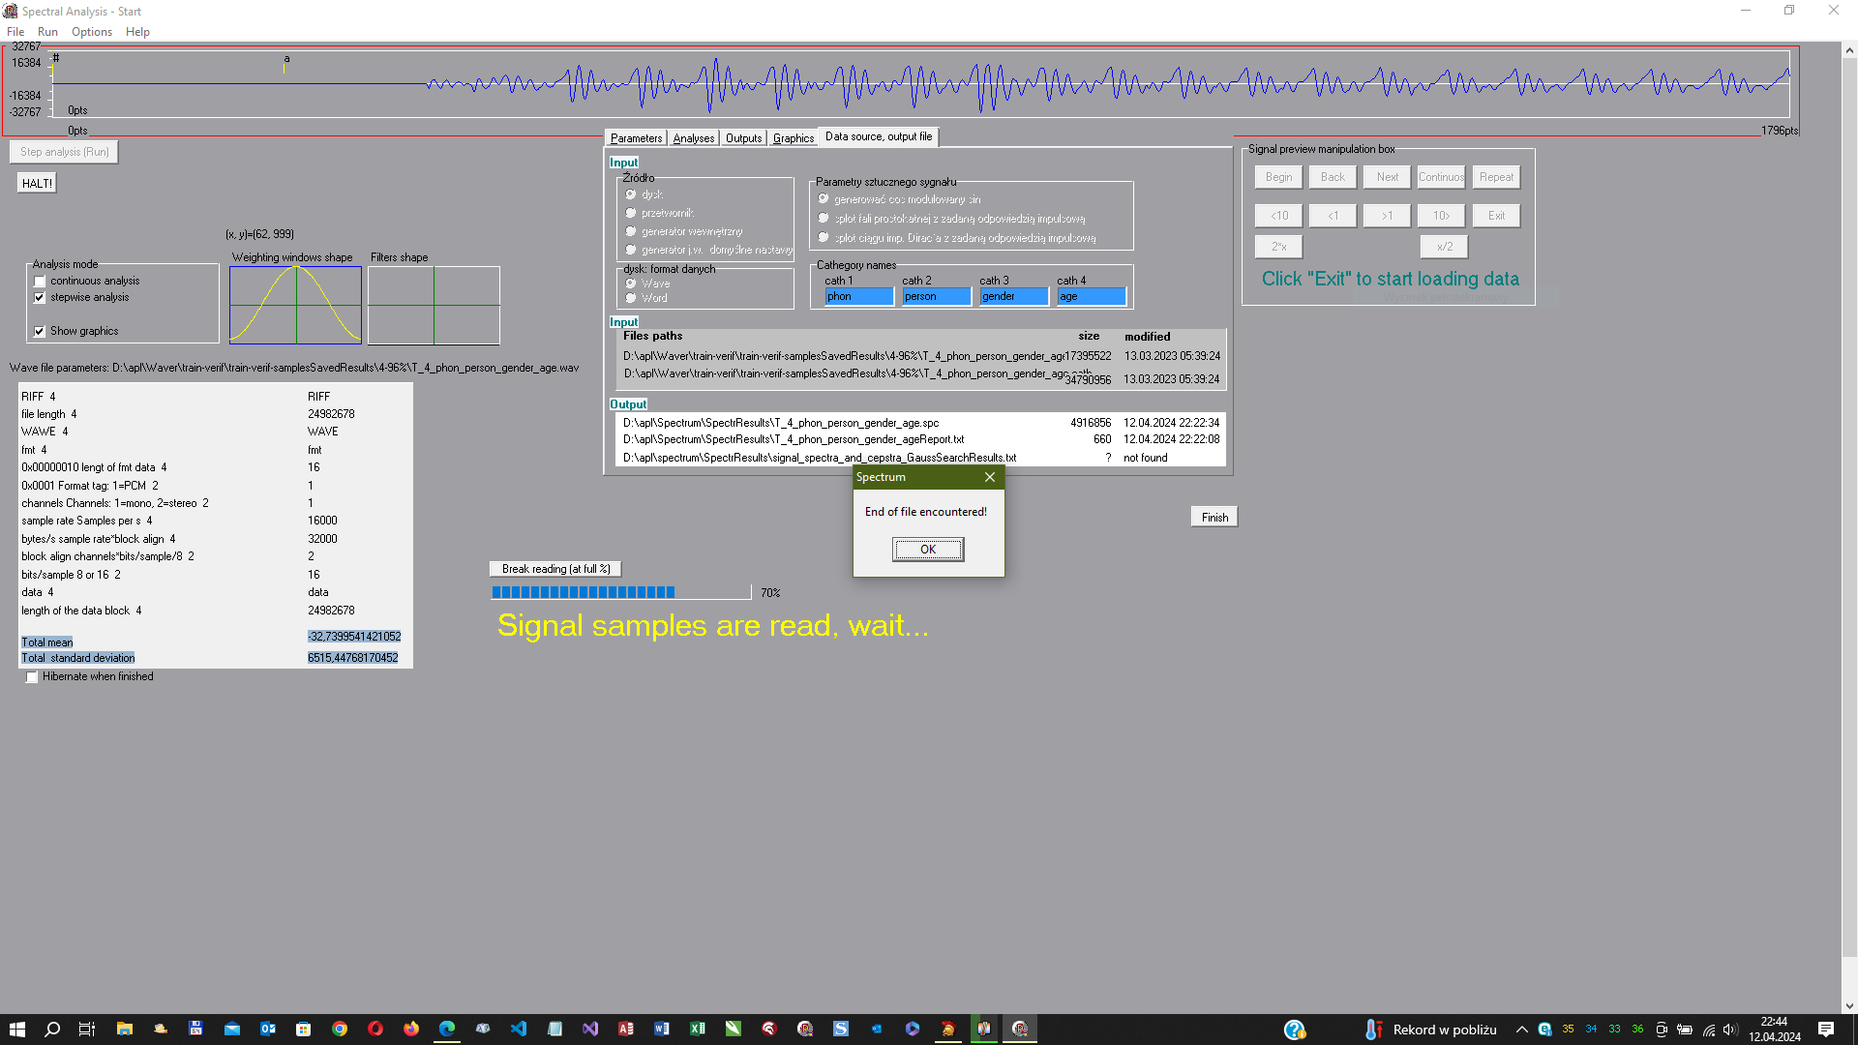

Screen shot, the “Visual Window” (from D12 version)

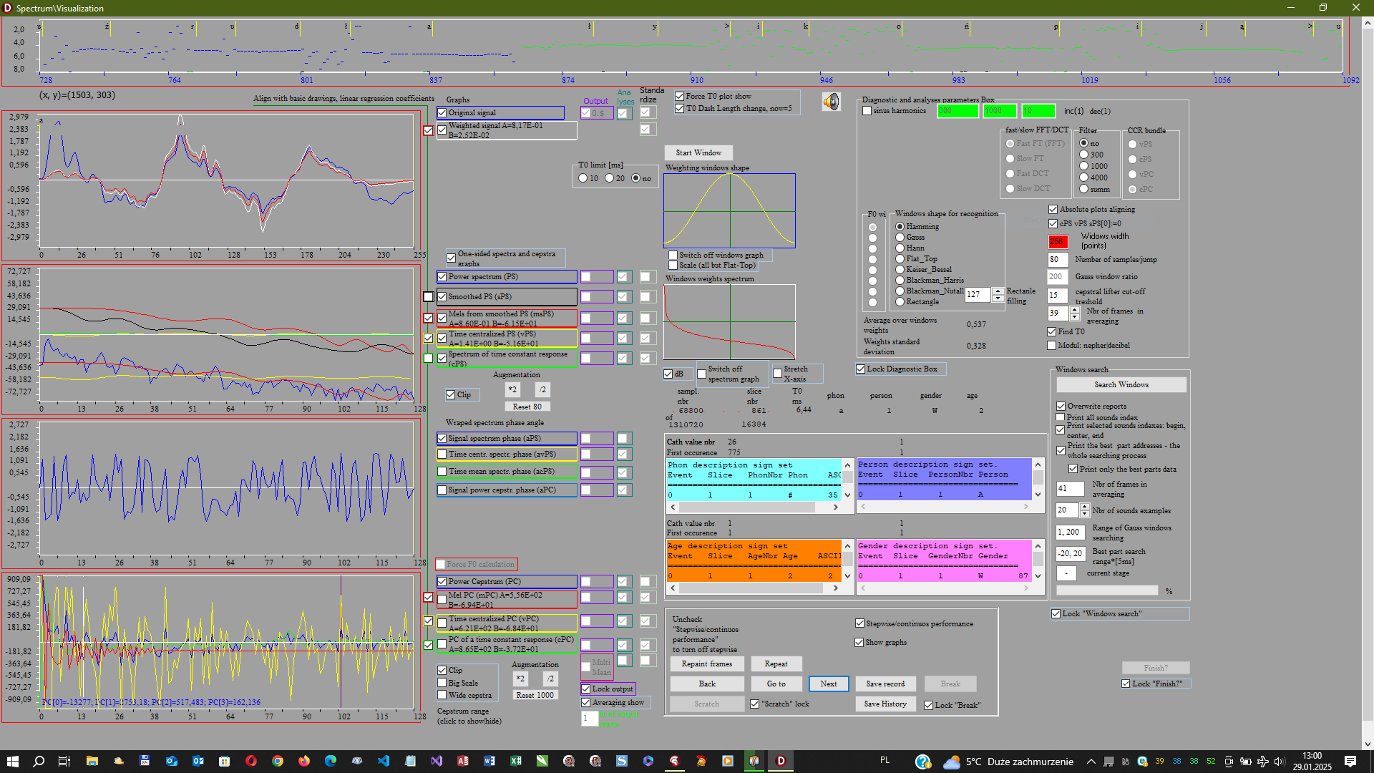

Spectra Reader Screen shot

